Tableau Server Installation on Oracle Linux8

Prerequisites:
- OL8
- Load balancer request
- Certs Creation
- Tableau software installation and Preparing file directories.
- TSM page activation
- Adding other nodes using bootstrap file
- Configuring SSl and SAML.

Application Name | Hostname | IP address
Tableau | sv2lxtabapst101 | 10.193.153.111
Tableau | sv2lxtabapst102 | 10.193.153.102
Tableau | sv2lxtabapst103 | 10.193.153.110

1.OL8
1.1 Version Details
1.2 Raising RITMs for new VMs

1.1 Version Details:
NAME="Oracle Linux Server"
VERSION="8.8"
RAM: 58GB
CPU(s): 16
1.2 Raising RITMs for new VMs
we should raise a request for a New VM’s using below Service-now link below.
https://equinix.service-now.com/sp?id=sc_cat_item&sys_id=86d639cb3d4ad040dc3e2358ceb6df9b
Below are RITMs what we have raised for procurement of new VMs.
RITM1253632
RITM1253634
RITM1253633
After clicking on the above link, one blank page will open as shown below there we should give the details as per the requirement.
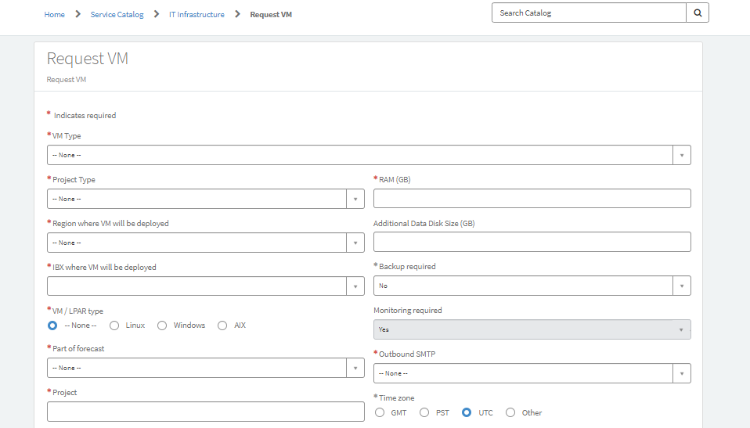

After giving all the details as per our requirement, RITM’s will be created.
Here you can see that our details matched as per our request by giving RITM number as seen below.
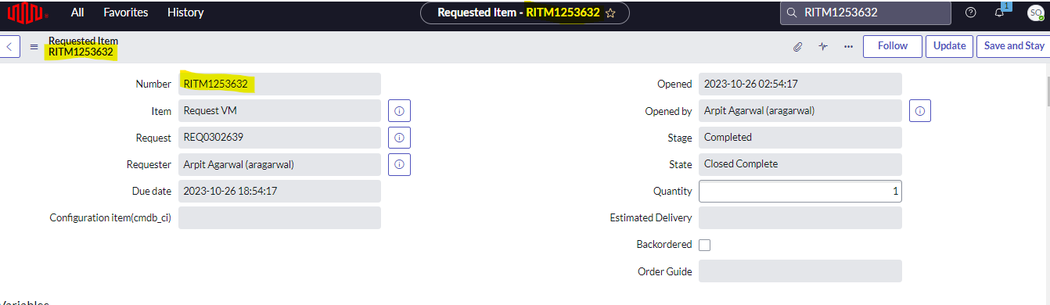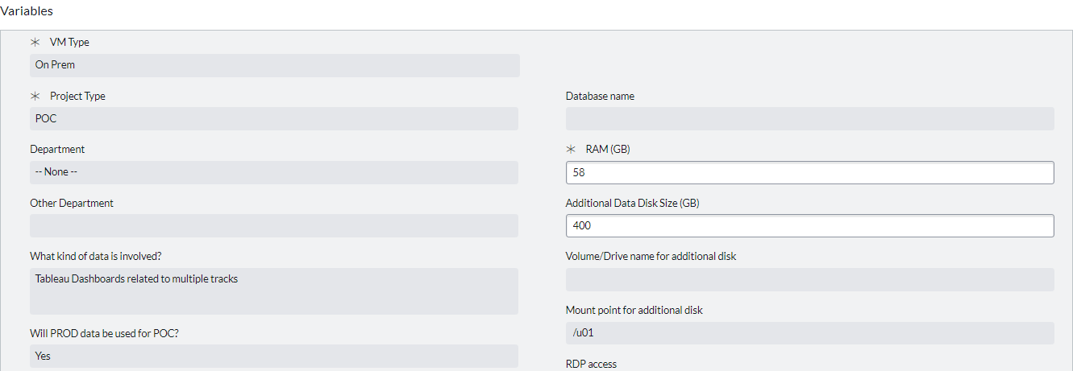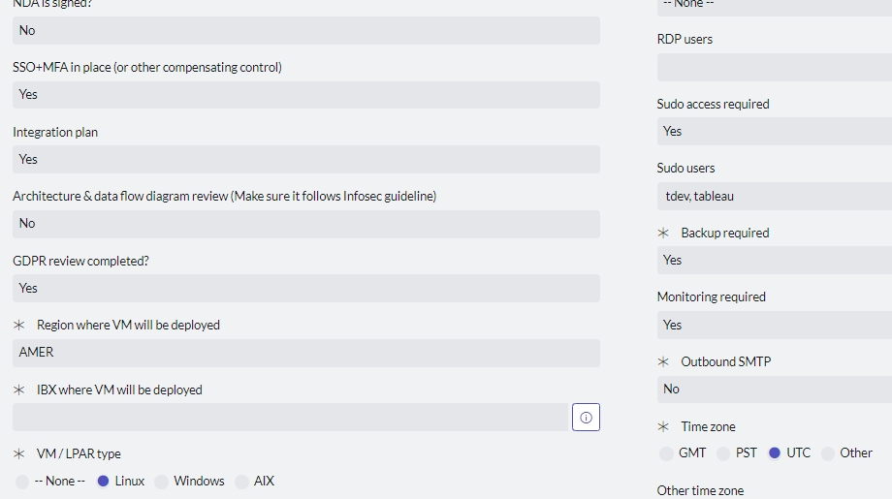
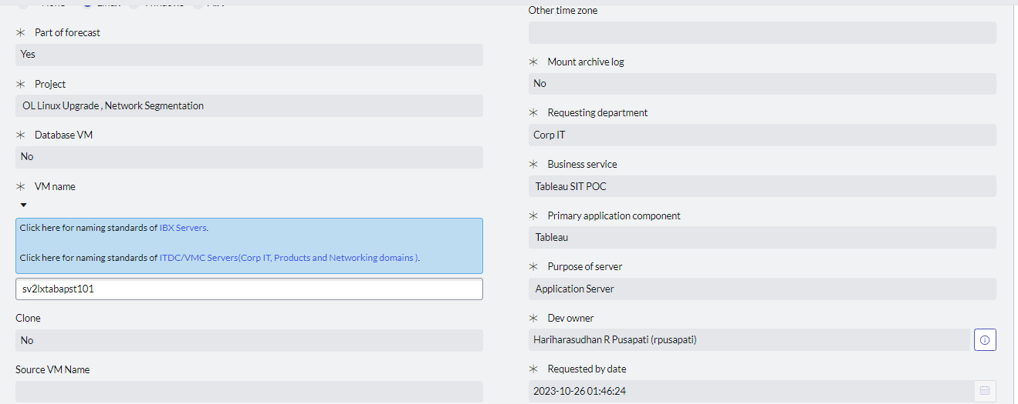
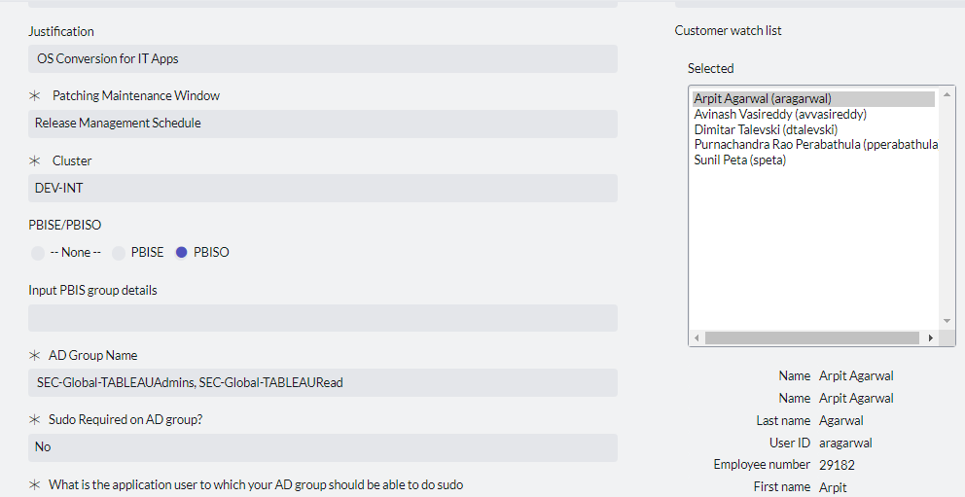
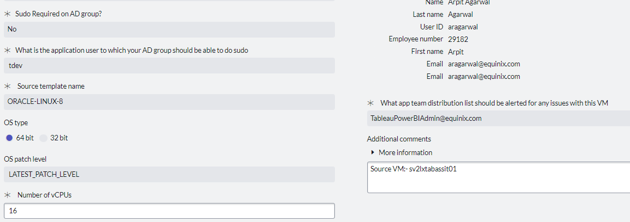

2. Load Balancer
Below is the RITM what we have raised.
RITM1259101
We request for Load balancer by using below link.
https://equinix.service-now.com/sp?id=sc_cat_item&sys_id=db9d4bda18cce900d4eb028eba7ee75e
After giving all the details, RITM will be created.
Here you can see that our details matched as per our request by giving RITM number as seen below.
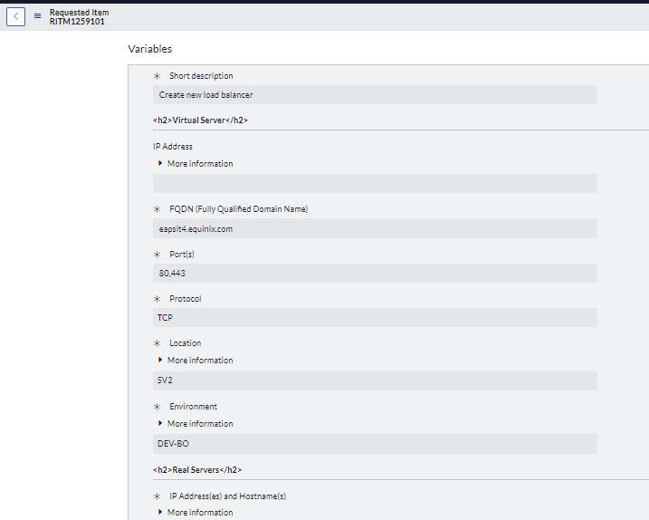
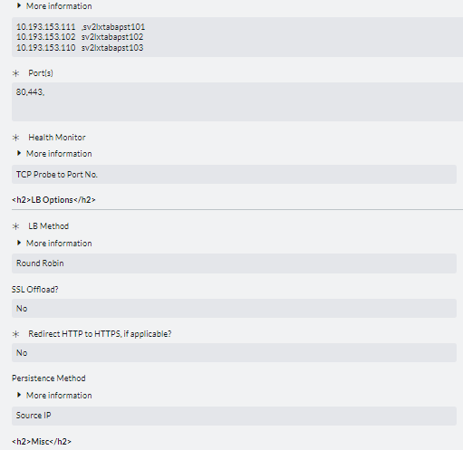
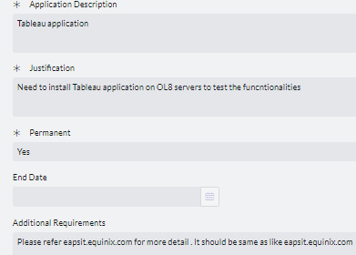

3. Certs Creation
For creating Certs follow the below link.
https://equinixjira.atlassian.net/wiki/spaces/EAO/pages/145470559033/Certificate+Creation

4. Tableau software installation and Preparing file directories.
4.1 Downloading Tableau software.
4.2 Initializing Tableau software.
4.3 Running acceptula command in primary node.

4.1 Downloading Tableau software.
Step 1
After getting all these things we need to start the Tableau installation.
To Install we should login into Jump server by giving server name with respective instance (Prod/Non-prod) as shown below.
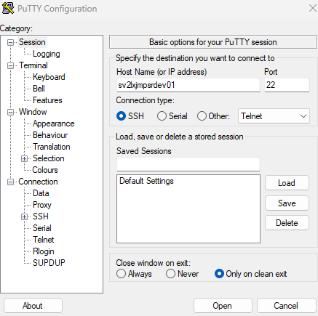

Step 2
After logging into jump server, the below screen will appear.
Here we use our credentials to login as shown below.
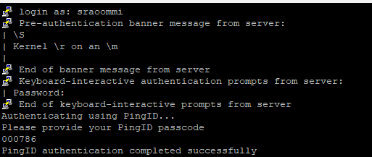

Step 3
Then we should login into respective server by giving command ssh sv2lxtabapst101
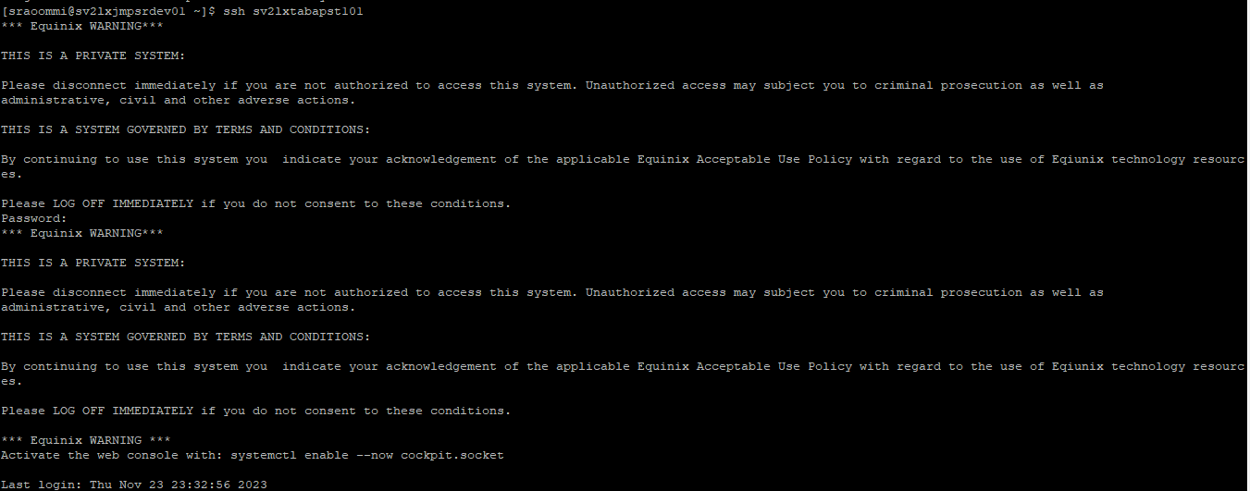

Step 4
Then login to sudo user by giving command sudo su – tdev

Step 5
We should create a directory by giving command sudo mkdir app as shown below
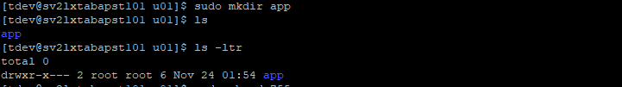

Step 6
To provide read/write permission for the directory by giving command sudo chmod 755 app as seen below.
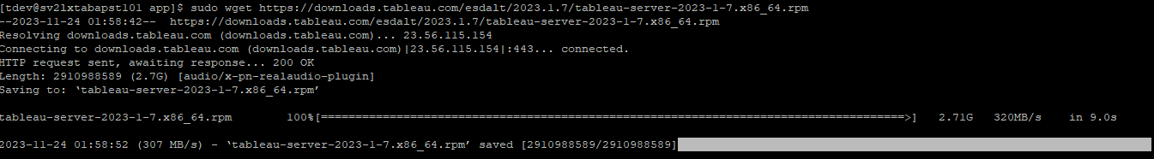

Step 7
We should move to the app folder and download rpm file.

Step 8
Now we should install dependencies by using the commands below.

sudo yum install gdb
sudo yum install chrpath
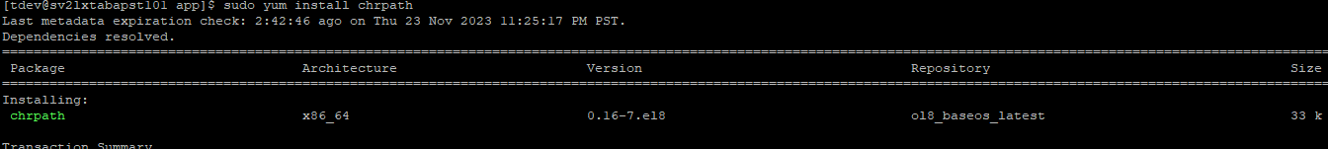
sudo yum install redhat-lsb-core
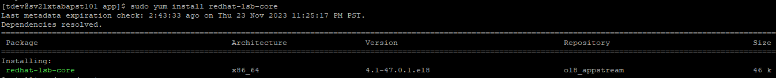

4.2 Initializing Tableau software.
Step 1
We must run the below cmnd to Install the Tableau Server.
sudo rpm -ivh --prefix /u01/app/tableau/ tableau-server-2023-1-7.x86_64.rpm
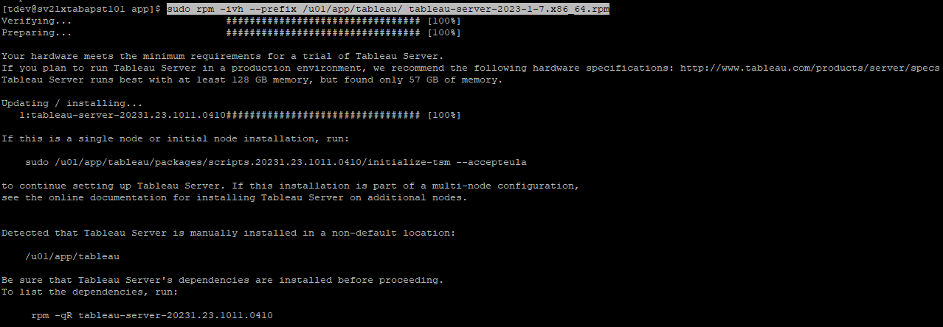

We must follow all the above steps in all nodes.

4.3 Running acceptula command in primary node.
To Initialize Tableau, we run the below command in node1(primary node).
sudo /u01/app/tableau/packages/scripts.20231.23.1011.0410/initialize-tsm --accepteula -d /u01/app/tableau/tableauserver -f.

After installation is completed, we provide access to TSM page to login by giving below command
5.TSM page activation
Step 1
Before we login to the TSM page we need to run the below command in the primary node of the server to get the access of the TSM page.
sudo usermod -a -G tsmadmin sraoommi
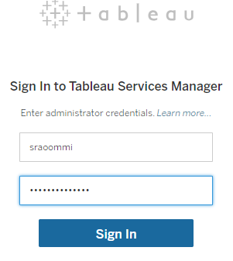
Step 2
Once we sign into TSM it will open the TSM page in the first screen we will give the license key and activate it and in the next screen we should provide the port details, default port will be 80 for tableau gateway.
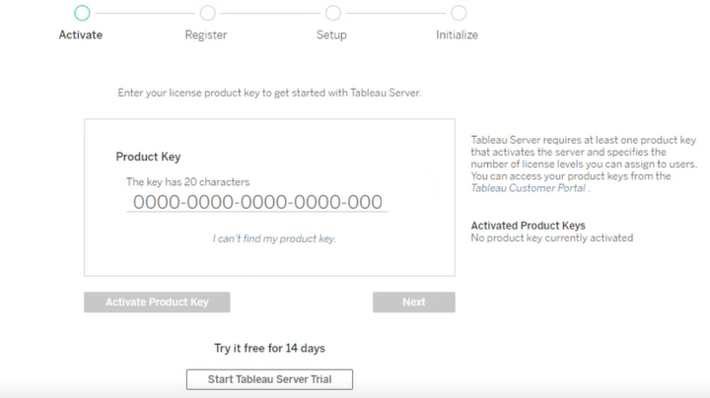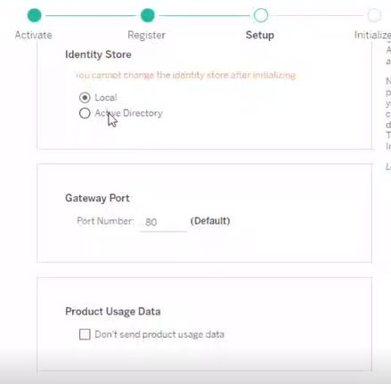
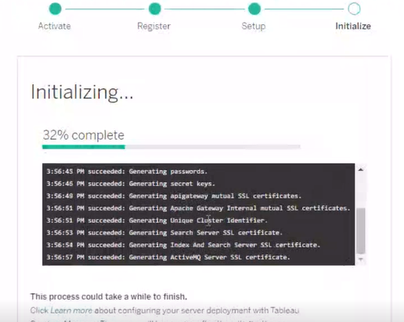

Step 3
After installation is completed, we should add the initial Admin user and password to login into tableau environment.
tabcmd initialuser --server http://localhost --username tadmin --password
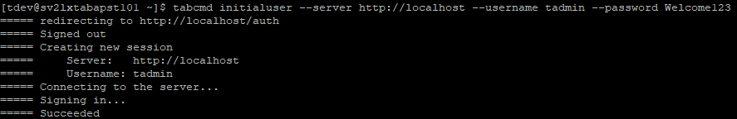

Step 4
After completion of adding initial user in server first we need to login to TSM page by the below URL and we need to check the status that all the services are up and running.
URL:- https://sv2lxtabapst101:8850
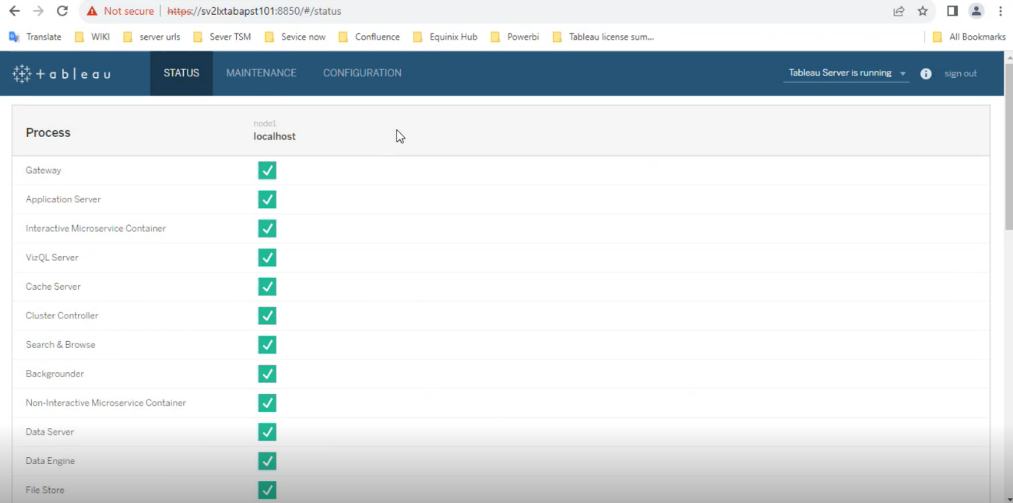

Step 5
After checking the status of services then we need to move to configuration page there we need to move to Topology section here we need to add the services what we are having in the previous environment like adding Backgrounders VizQL Server etc.
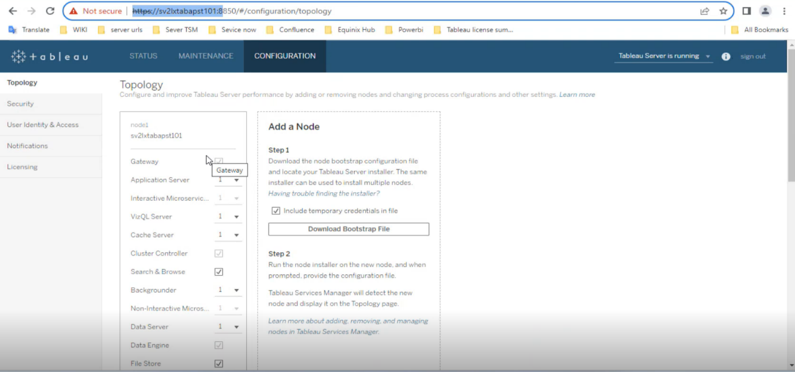

6.Adding other nodes using Bootstrap file
Note: Importance of Bootstrap
After installing we will get the bootstrap file from the initial node and move the file to the node which we are adding there after installing the initializer we will initialize with the bootstrap file after the process is completed node will be added to the cluster and can be displayed in the TSM page,
Same process will be repeated for all the nodes which we add
The main motive of building HA cluster is if any issue occurs on the initial node we can move all the licensed processes to the active node and remove the affected node from the cluster and make environment up and running.

Below are the steps to follow to adding other nodes by using Boostrap file.
Step 1
For adding additional nodes, we need to move to the configuration page, and we need to click on the download bootstrap file option.
After completion of downloading the bootstrap file, we need to open the file in the notepad. The boot strap file format we will be as shown below.
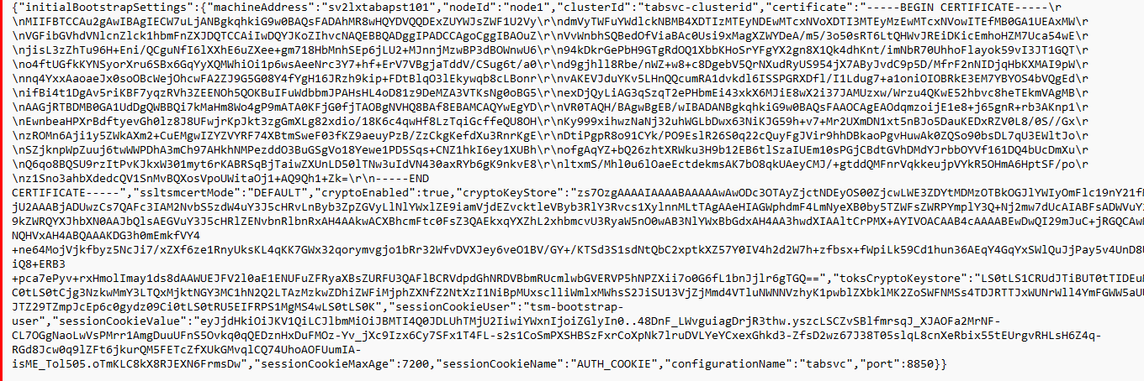

Step 2
We need to create a file with the command sudo vi bootstrap.json. After completion of creating a file, we need to open the file and copy the bootstrap data.

Step 3
We need to change the file permission by using the below command.
Sudo chmod 775 bootstrap.json

Step 4
Next, we need to move to scripts folder under tableau/packages, in the scripts folder we need to open the present repository then after that we need to run the below command to install nodes successfully.
sudo ./initialize-tsm -b /u01/app/bootstrap.json --accepteula -d /u01/app/tableau/tableauserver/ -f
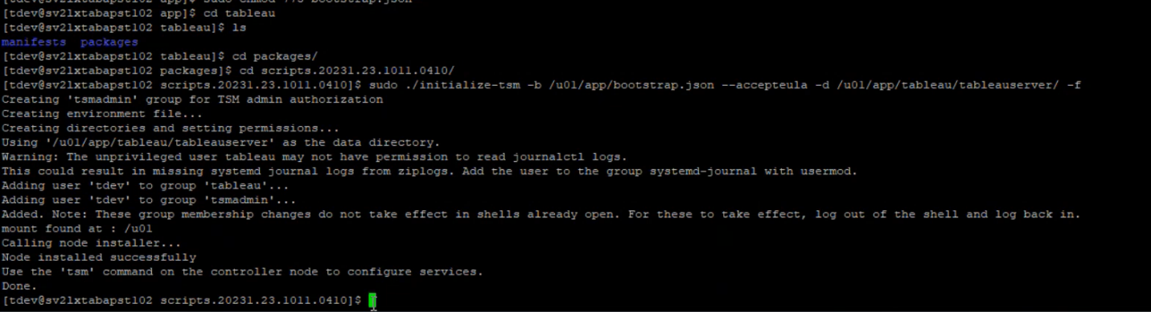

Step 5
After completion of adding the nodes successfully we need to login to the TSM page. We need to move to the configuration and there we need to add the processes as per our requirement. After that we need to click on the pending changes and click on apply changes, then the services will restart, and we can confirm all the processes are added by clicking on the status tab on the TSM page.
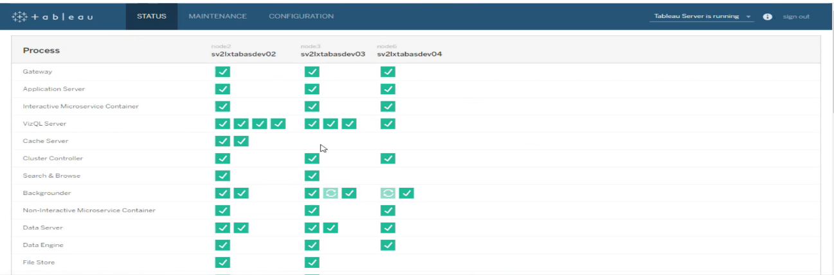
We need to follow the above steps in the remaining servers to add a node.

7 Configuring SSl and SAML.
Note: SSL
To generate SSL certificate we require .key file a CSR file
By setting up open SSL we will generate .key file and by using .key file we will generate CSR file
We will provide both the files to your CA team and request for certificate and chain certificate.
Certificate is used to enable HTTPS traffic server and chain certificate is used to connect other clients like tableau desktop, tests mobile.
After getting certificate and chain certificate
We will log into TSM page and in the configuration we can see security page then in SSL we will upload .certi,.keycerti,.chaincertificate and enable SSl.

Below are the steps to follow for confirguring SSL
Step 1
For enabling SSL we need to login into the TSM page we need to click on the configuration tab and need to move to the security there we need to upload the certificates like keycer, server cert and chain cert as seen below.
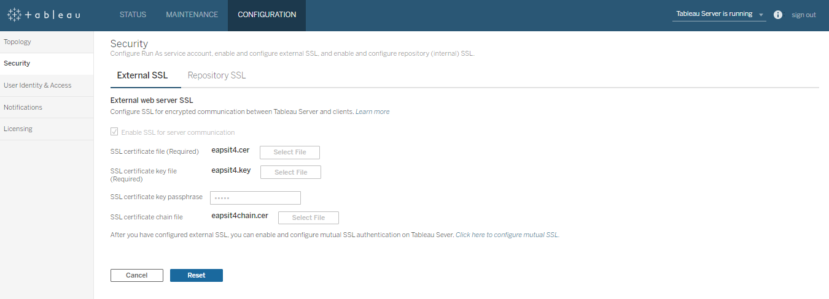

Step 2
Then after that we need to click on the pending changes and click on apply changes, then the changes will take place by restarting the services.
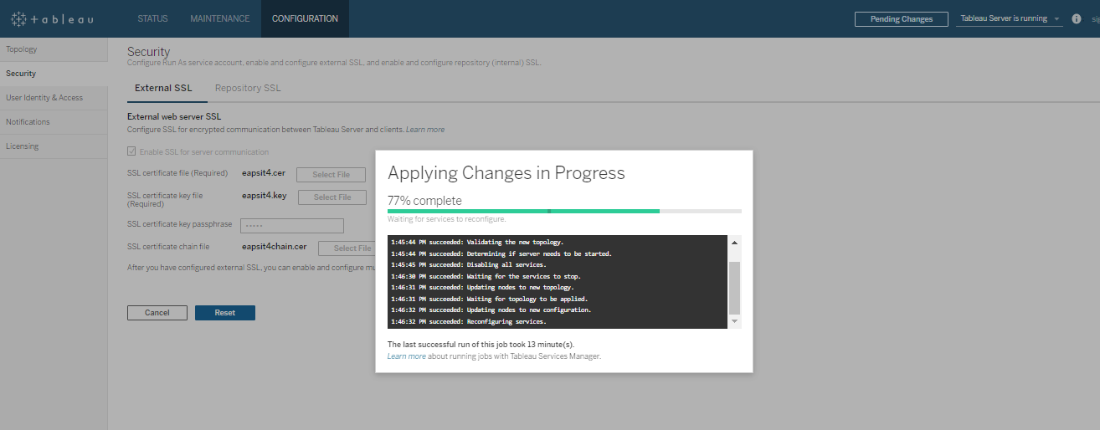

SAML
To enable SMAL we can use the .cer and .key file generated for SSL
Go to configuration security tab in the SSO option we will select SAML and upload the certificates and provide the URL details of our tableau server And download XML metadata file and provide to IDP team and they will give one meta data file and we upload it and enable SAML .
Below are the steps to follow for confirguring SAML.
Step 1
For enabling the SAML we need to login into the TSM page. We need to click on the configuration tab in there we need to move to User identity and access there we need to click on the Authentication Method.
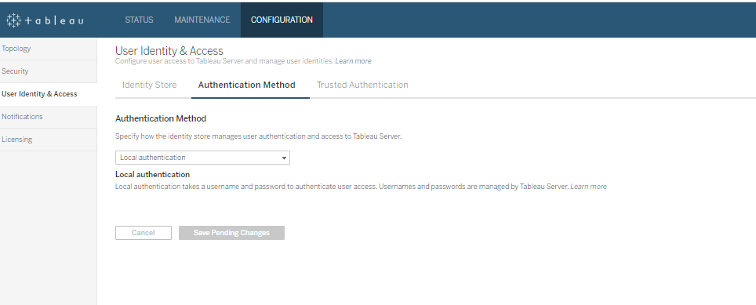
Step 2
There in drop down we select SAML, after that we need to download metadata file and we need to send that metadata file to IDP team then they will provide us the updated IDP metadata file.
By using the below link we need to raise RITM for IDP team to provide us the updated IDP Metadata file.
https://equinix.service-now.com/com.glideapp.servicecatalog_cat_item_view.do?v=1&sysparm_id=6f473548db86b70024e02b35ca96192e
RITM No.
RITM1260463

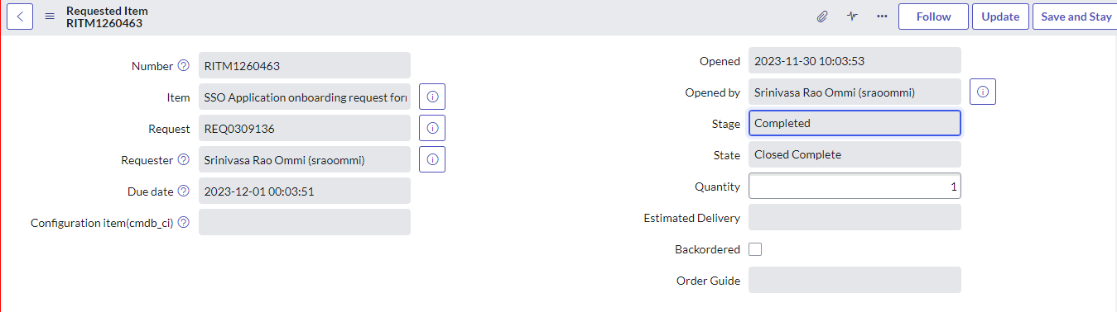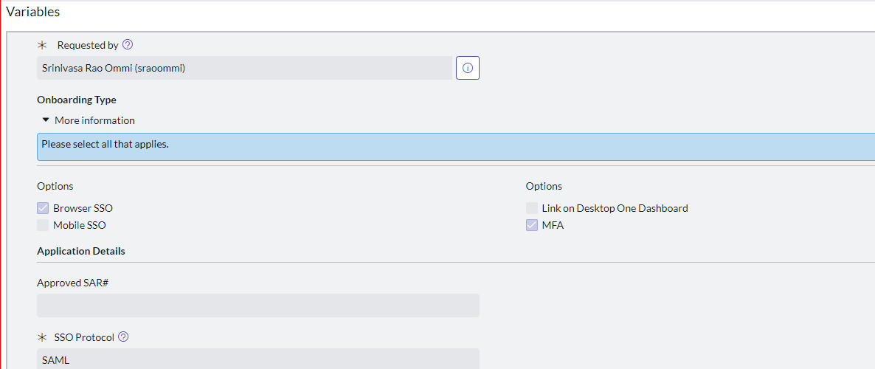
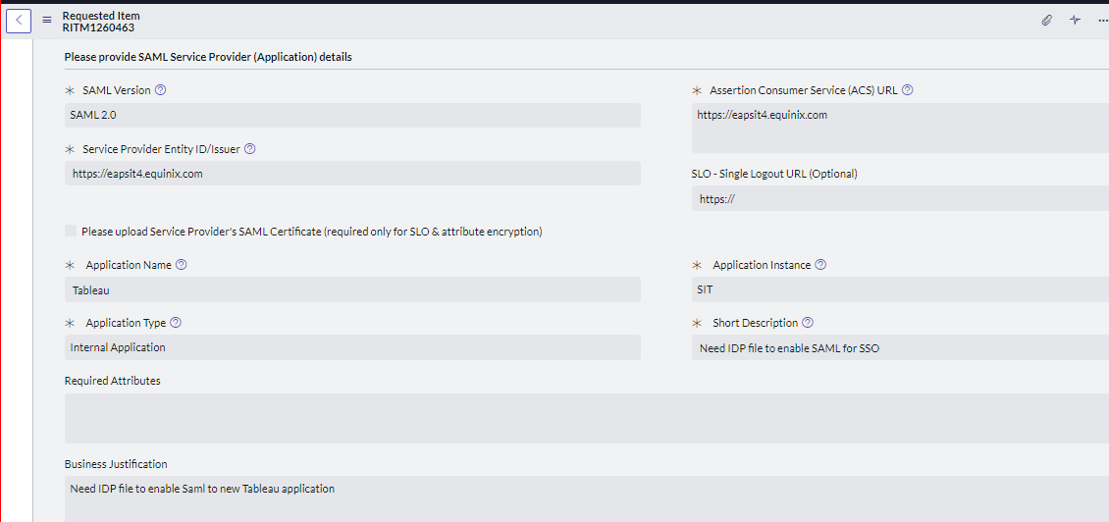

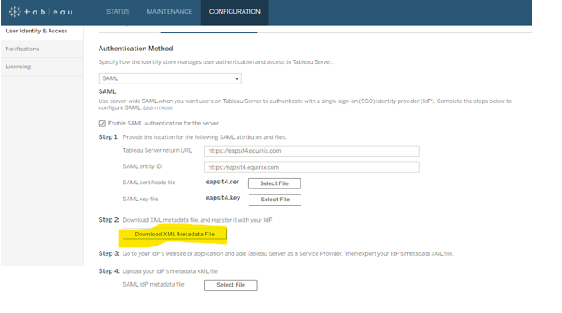

Step 3
After receiving the metadata file, we need to upload the file in the Authentication Method page and, we need to provide the required details and upload the certificates as shown below.
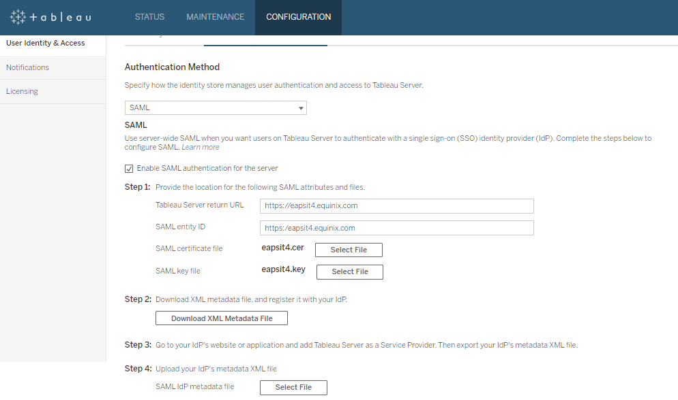
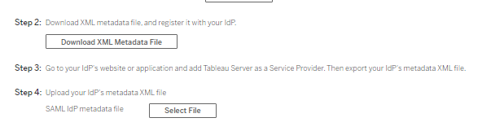
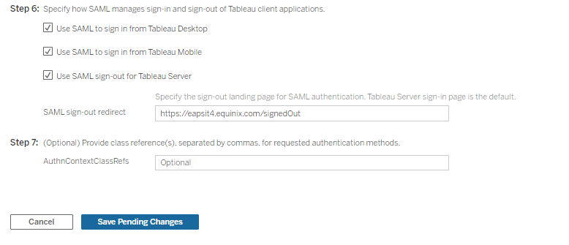
Step 4
After uploading the details, we need to click on pending changes then after that we need to click on apply changes, then the services will restart, and changes will be reflected.

